NAME:Rishik JK
REG.NO :192511052

CSA1708-ARTIFICIAL INTELLIGENCE
LAB EXPERIMENT

Experiment 1 – 8-Puzzle Problem

AIM
To write a Python program to solve the 8-Puzzle Problem.

ALGORITHM
- Start with an initial 3 × 3 puzzle state.
- Represent the empty space using 0.
- Find the position of the empty space.
- Move the empty space up, down, left, or right wherever possible.
- Generate new puzzle states after each valid move.
- Continue searching until the goal state is reached.
- Display the solution.
- Stop the program.

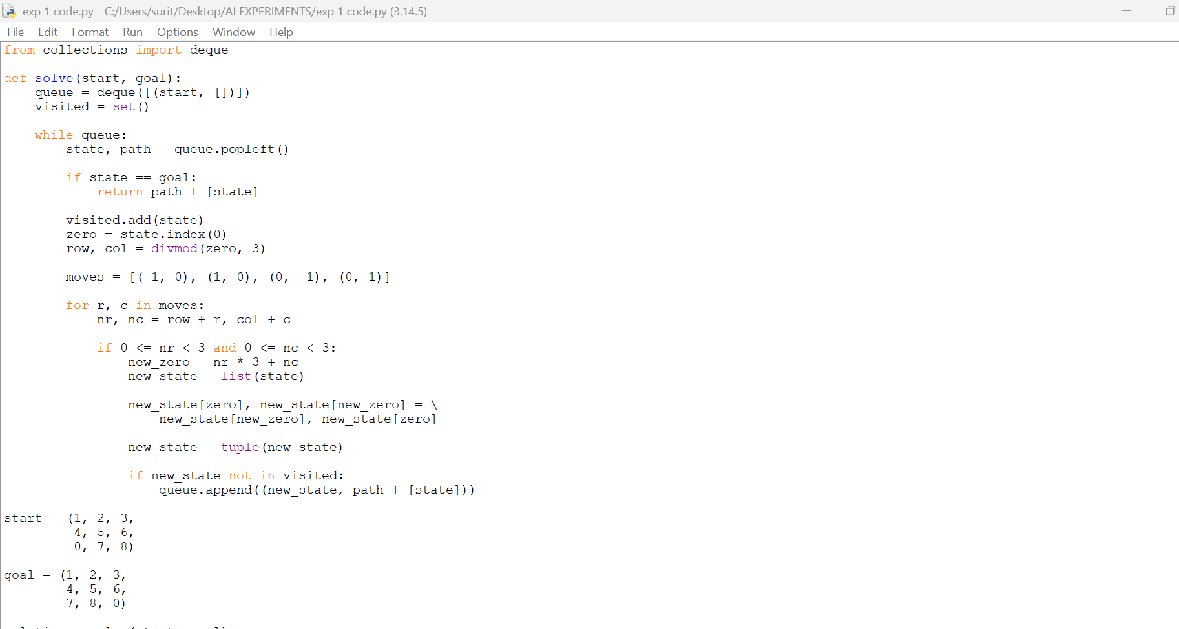
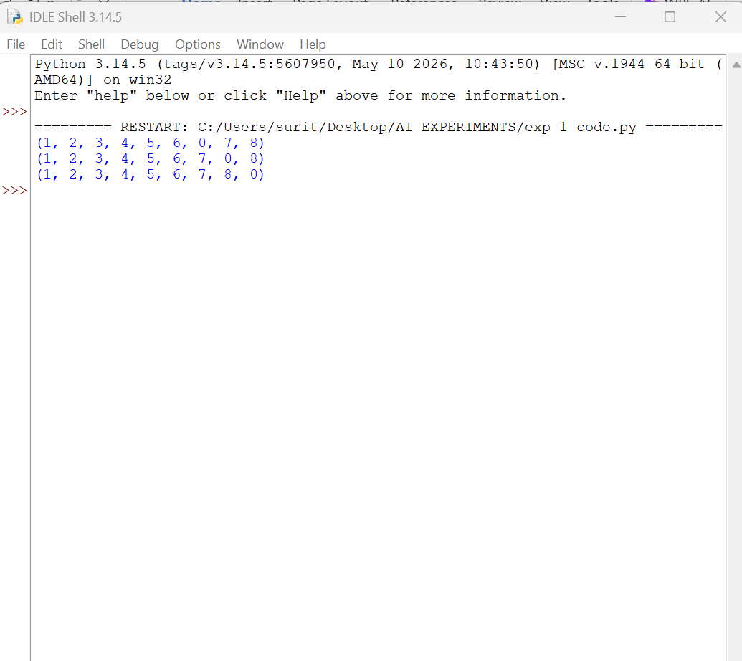

RESULT:
Thus, the 8-Puzzle Problem was successfully solved using the Breadth First Search (BFS) algorithm in Python.

